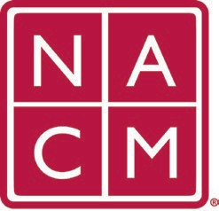
National Association
for Court Management Strengthening Court Professionals
WEBSITE COMMITTEE
January 4, 2023 @ 2:00 p.m. ET
Chair: Roger Rand
Committee Page
- Review and Approval of minutes from December 7, 2022 Meeting.
- Old Business
  - Core Champion Page
    - Website Management – need backup
    - Next Steps needed from board
- New Business
  - MidYear Conference 2/5-2/7
- Future Meetings
  - Roger will be unavailable on 2/1/23
Future Meeting dates.

February 1, 2023 June 7, 2023
March 1, 2023 July TBD at Annual Conference
April 5, 2023
Thank you for your time and we look forward to working with you this NACM year.
Association Services: National Center for State Courts, 300 Newport Avenue, Williamsburg, VA 23185 (757) 259-1841, Fax (757) 259-1520
Home Page: http://www.nacmnet.org

