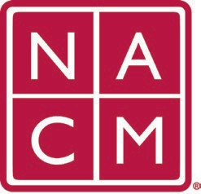
National Association
for Court Management Strengthening Court Professionals
WEBSITE COMMITTEE
January 4, 2023 @ 2:00 p.m. ET
Chair: Roger Rand
Committee Page
- Review and Approval of minutes from December 7, 2022 Meeting.
- Old Business
  - Core Champion Page
    - Website Management – need backup
    - Next Steps needed from board
      - Registered creative created the CORE site and were acquired by Liquid Web who is owned by Nexess. Erin reports that we paid Nexess $190 last May for annual hosting charges. Roger to contact Nexcess to obtain an additional account so that the Web Team can sign in and create restore points for updates.
      - Erin Will contact Howell and ask them for a quote to add the CORE site to our website maintenance and support package that we have for the NACMNET.ORG site.
  - Website Committee Meeting Zoom Link

- New Business
  - MidYear Conference 2/5-2/7
Rick reports that all of the education sessions and speakers are confirmed.
Hotel block ends next Friday
- Future Meetings
  - Roger will be unavailable on 2/1/23. Next Meeting will be March 1, 2023.
Future Meeting dates.

February 1, 2023 (Cancelled) June 7, 2023
March 1, 2023 July TBD at Annual Conference
April 5, 2023
Thank you for your time and we look forward to working with you this NACM year.
Association Services: National Center for State Courts, 300 Newport Avenue, Williamsburg, VA 23185 (757) 259-1841, Fax (757) 259-1520
Home Page: http://www.nacmnet.org

