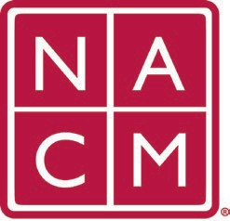
National Association
for Court Management Strengthening Court Professionals
WEBSITE COMMITTEE
March 1, 2023 @ 2:00 p.m. ET
Chair: Roger Rand
Committee Page
- Review and Approval of minutes from January 4, 2023 Meeting.
- Old Business
  - Core Champion Page
    - Demonstration of new page
    - Discussion
  - Change Requests
    - 2/10/23 Request menu item changes for CORE site
    - 2/24/23 Request to add Social Media Subcommittee Page
  - Howell to John Thomas switch 4/1/23
    - Meeting
  - Document Library
    - Past Conference Materials
- New Business
  - Video Gallery – Name Change?
  - Open Discussion
Future Meeting dates.

April 5, 2023 June 7, 2023
May 3, 2023 July TBD at Annual Conference

Thank you for your time and we look forward to working with you this NACM year.
Association Services: National Center for State Courts, 300 Newport Avenue, Williamsburg, VA 23185 (757) 259-1841, Fax (757) 259-1520
Home Page: http://www.nacmnet.org

