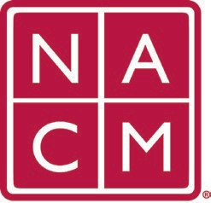
National Association
for Court Management Strengthening Court Professionals
WEBSITE COMMITTEE
November 2, 2022 @ 2:00 p.m. ET
Attendees: Mae Swisher, Tom Hathaway, Joe Calogero, Kelly Steele, Kent Pankey, Rick Pierce
- Review and Approval of minutes from October 5, 2022 Meeting.
- Change Requests (Roger)
  - Conference Page Demonstration (Mae Swisher)
This demonstration was recorded and a link to the recording is here:
  - CORE Change (Kelly Hutton)
- Old Business
  - Communication with Howell
Howell is charging us for breaks/fixes that result from any update
Agreed upon communication improvements
Howell will continue to be our website vendor and their services are needed
  - Site Updates (Kelly Steele)
Kelly went over examples of issues on our site.
Resources: There are too many resources/publications in the mega menu
Need to reduce the number of links – Mae said we should limit ourselves to 5 links
Resolutions are under education – and it should really be under governance
We need to make sure that if we do have a mega menu that the same items in the mega menu should also be on the linked page. This problem will go away if we eliminate the mega menu.
NACM Store and NACM Swag
The Style Guide – why is this available to the general membership?
Discussion: Web site should not be used as a historical archive. We should have archived documents elsewhere.
  - Mail Chimp Issue for Core - resolved
- New Business
  - Resource Index and Past Presidents (Norman Meyer)
- Future Meetings
Future Meeting dates.

December 7, 2022 June 7, 2023
January 4, 2023 July TBD at Annual Conference
February 1, 2023
March 1, 2023
April 5, 2023
Thank you for your time and we look forward to working with you this NACM year.
Association Services: National Center for State Courts, 300 Newport Avenue, Williamsburg, VA 23185 (757) 259-1841, Fax (757) 259-1520
Home Page: http://www.nacmnet.org

