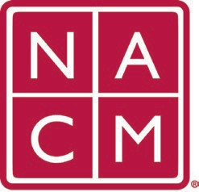
National Association
for Court Management Strengthening Court Professionals
WEBSITE COMMITTEE
November 2, 2022 @ 2:00 p.m. ET
Chair: Roger Rand
Committee Page
- Review and Approval of minutes from October 5, 2022 Meeting.
- Change Requests (Roger)
  - Conference Page Demonstration (Mae Swisher)
  - CORE Change (Kelly Hutton)
- Old Business
  - Communication with Howell
  - Site Updates (Kelly Steele)
  - Mail Chimp Issue for Core - resolved
- New Business
  - Resource Index and Past Presidents (Norman Meyer)
- Future Meetings
Future Meeting dates.

December 7, 2022 June 7, 2023
January 4, 2023 July TBD at Annual Conference
February 1, 2023
March 1, 2023
April 5, 2023
Thank you for your time and we look forward to working with you this NACM year.
Association Services: National Center for State Courts, 300 Newport Avenue, Williamsburg, VA 23185 (757) 259-1841, Fax (757) 259-1520
Home Page: http://www.nacmnet.org

