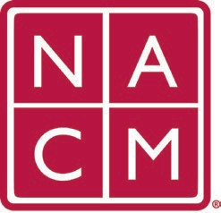
National Association
for Court Management Strengthening Court Professionals
WEBSITE COMMITTEE
October 5, 2022 @ 2:00 p.m. ET
Chair: Roger Rand
Committee Page
- Review and Approval of minutes from September 7, 2022 Meeting.
- Change Requests (Roger)
  - Conference Page Update
  - Membership Change Request
  - CORE Change Request
- Email Concerns/Issues
  - Court Express
    - Current issues in archive?
    - 2022 issues were not present - resolved
  - Search Function
    - Howell workaround
  - Mega Menu on Mobile
- New Business
- Future Meetings
Future Meeting dates.
March 1, 2023
October 13, 2022 April 5, 2023
December 7, 2022 June 7, 2023
January 4, 2023 July TBD at Annual Conference
February 1, 2023
Thank you for your time and we look forward to working with you this NACM year.
Association Services: National Center for State Courts, 300 Newport Avenue, Williamsburg, VA 23185 (757) 259-1841, Fax (757) 259-1520
Home Page: http://www.nacmnet.org

