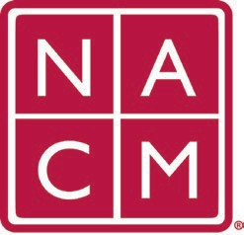
National Association
for Court Management Strengthening Court Professionals
WEBSITE COMMITTEE
September 7, 2022 @ 2:00 p.m. ET
Chair: Roger Rand
Committee Page
- Welcome and Introductions
- Goals for 2022-2023 NACM Year
  - Website Setup (Done!)
  - Add/Change Form Created (Done!)
  - New Conference Page
- Website Overview (Roger/Angie)
  - Nacmnet.org
  - nacmcore.org
- Committee Structure and Work Plan
  - Working Committee
  - Roles and Responsibilities
    - Howell vs Committee
    - Developers vs Non-Developers
  - Communication
    - Email
    - Monthly Meetings
    - Change Request Form
- Current Change Requests
  - Conference Page
    - Howell
    - Removal of Calendar Widget
- Future Meetings
Future Meeting dates.
October 5, 2022 March 1, 2023
October 13, 2022 April 5, 2023
December 7, 2022 June 7, 2023
January 4, 2023 July TBD at Annual Conference
February 1, 2023
Thank you for your time and we look forward to working with you this NACM year.
Association Services: National Center for State Courts, 300 Newport Avenue, Williamsburg, VA 23185 (757) 259-1841, Fax (757) 259-1520
Home Page: http://www.nacmnet.org

