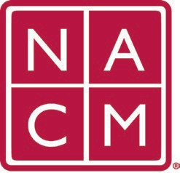**National Association**

**for Court Management *Strengthening Court Professionals***

**WEBSITE SUBCOMMITTEE**

**Agenda**

**September 4, 2024 @ 1PM PT / 4PM EST**

Chair: [Jeffrey](mailto:jeffrey@nacmnet.org?subject=NACM%20Website%20Committee) Tsunekawa

[Committee Page](https://nacmnet.org/committees/standing-committees/communications-committee/website-subcommittee/)

1. Welcome – Jeffrey
2. 2024 Website Projects

* Document Library – Update from John Thomas
* NACM Swag Page – Jeffrey/Tom
* Image Optimization
* Broken Link Report – Need Volunteer(s)
* 404 Errors and Redirect Pages – Need Volunteer(s)

1. Old Business/Standing Agenda Items
   1. Member Portal Landing Page
   2. Mentor Program Landing Page
   3. Join Us / Dual Partners
2. New Business:

* The order of committees on the committee page is out of line with current NACM bylaws. Remove the Finance Committee. Governance is a permanent committee and should be in the right column. Past Presidents is a standing committee and should be in the left column.

**Future Meeting Dates:**

September 4 – *4:00 PM EST*

October 2

November 6

December 4 – TBD

**Thank you for your time!**

Association Services: National Center for State Courts, 300 Newport Avenue, Williamsburg, VA 23185 (757) 259-1841, Fax (757) 259-1520

Home Page[: http://www.nacmnet.org](http://www.nacmnet.org/)